10.102: Denoting the upward forces that the hands exert as 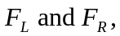the conditions that 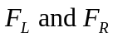must satisfy are
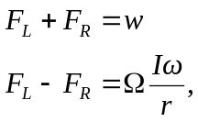
where the second equation is 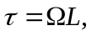 divided by r. These two equations can be solved for the forces by first adding and then subtracting, yielding
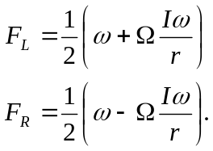
Using the values
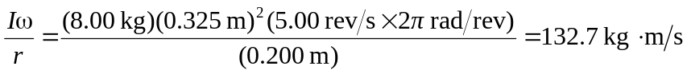
gives
